1. Overview
This prototype demonstrates a personalized math learning system for children aged 5–10, focusing on basic arithmetic (addition, subtraction, multiplication, division). The core innovation is dynamic difficulty adjustment using a lightweight machine learning model (Decision Tree Classifier), trained on synthetic performance data to mimic intelligent adaptation.
The system keeps learners in their optimal challenge zone not too easy (boredom), not too hard (frustration) by analyzing correctness and response time.

2. Architecture & Flow
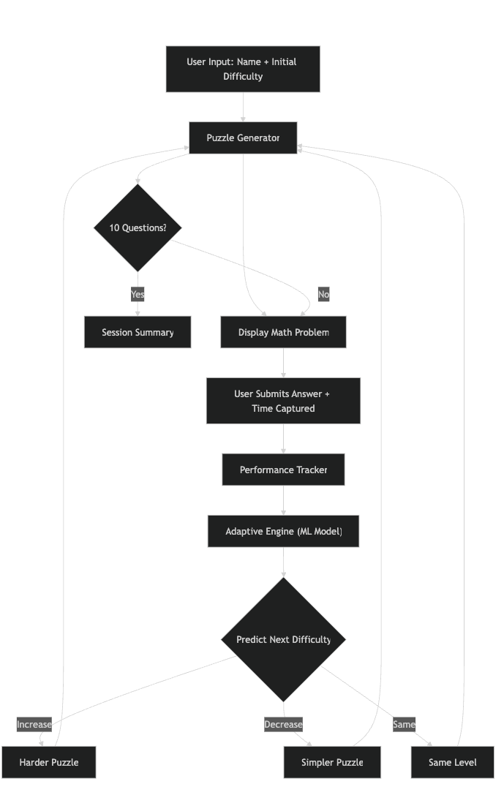
Components:
puzzle_generator.py: Generates operation-specific puzzles by difficulty.
tracker.py: Logs correctness and response time.
adaptive_engine.py: Trains and uses ML model to predict next difficulty.
main.py: Orchestrates flow in console.

3. Adaptive Logic: Lightweight ML Model
Model: DecisionTreeClassifier (scikit-learn)

Max depth: 3 (lightweight, interpretable, fast)
Input features:
Current difficulty level (0=Easy, 1=Medium, 2=Hard)
Correctness (1 = correct, 0 = incorrect)
Response time (seconds, continuous)

Training Data: Synthetic Dataset (1,000 samples)
Simulates realistic learner behavior:
if correct and time < 10s → increase difficulty
if incorrect or time > 20s → decrease difficulty
else → maintain difficulty

Prediction:
next_difficulty = model.predict([[current_idx, correct, time]])[0]

4. Key Metrics Tracked
We keep an eye on two simple but powerful things: whether the child gets the answer right and how long it takes them to answer.
If they get it correct and fast (usually under 10 seconds), it’s a clear sign they’re ready for something tougher like they’ve truly mastered that level. But if they get it wrong, or even if they get it right but take a really long time (say, over 20 seconds), it tells us they’re struggling. In those moments, we ease things up to keep them from feeling stuck.
The magic is that we don’t use strict rules the model learns these patterns naturally. For example, it can tell the difference between “got it right, but slowly” (maybe they’re unsure) and “got it wrong, but fast” (maybe guessing). At the end, we show a friendly summary: how many they got right and their average speed so both the child and teacher can see progress.
5. Why This Approach
We went with a tiny, smart decision tree think of it as a super-simple AI brain because it’s fast, easy to understand, and gets the job done without any fuss. It trains in a blink (less than a tenth of a second!) and doesn’t need fancy hardware.
Hard-coding rules like “if wrong twice, go down” can feel robotic and miss the nuance like when a child is slow but thoughtful. The tree learns from examples (we made up 1,000 realistic ones to start), so it adapts more like a patient teacher would. Plus, we can actually look inside it and see why it made a choice no black box.
Starting with fake data means the system works from day one, but the cool part? Later, we can feed it real answers from actual kids and it’ll get even smarter. It’s not overkill it’s just enough AI to show something real and impressive, perfect for a prototype that proves the idea works.

